Culture Insider: China's Ghost Festival

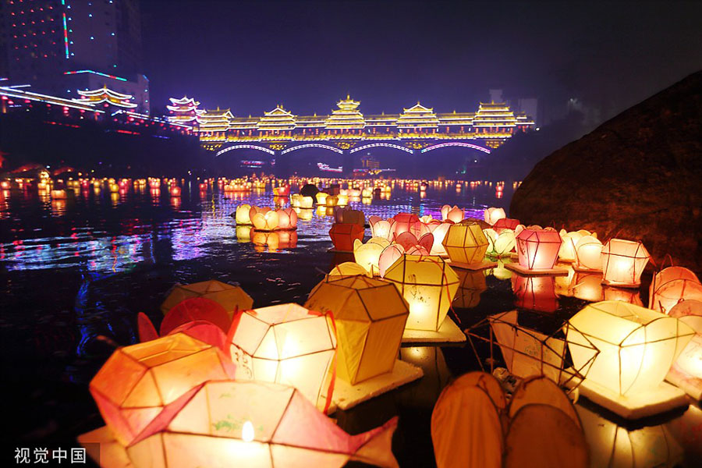

The Zhongyuan Festival, also known as Ullambana Festival among Buddhists, falls on the fifteenth day of the seventh lunar month, on Aug 30 this year.

Since ancient times, the Chinese have believed that the gates of hell open on that day and so people hold all kinds of activities to honor the ghosts. Therefore, the festival is also called the Ghost Festival.

There are two other festivals in China to honor departed spirits of ancestors: Qingming Festival (in spring) and the Chung Yeung Festival (in autumn). In both, living descendants pay homage to their deceased ancestors. Zhongyuan Festival is distinct from these, as the deceased are believed to visit the living.

Buddhist doctrine says that by offering articles on the festival day, deceased parents and relatives can be saved from bad situations in the after life. The Ullambana Festival of Buddhism has two meanings. One is to persuade people to provide for Buddhist monks. The other is to convince people to do more charitable deeds to release departed souls from sin and advocate family devotion.

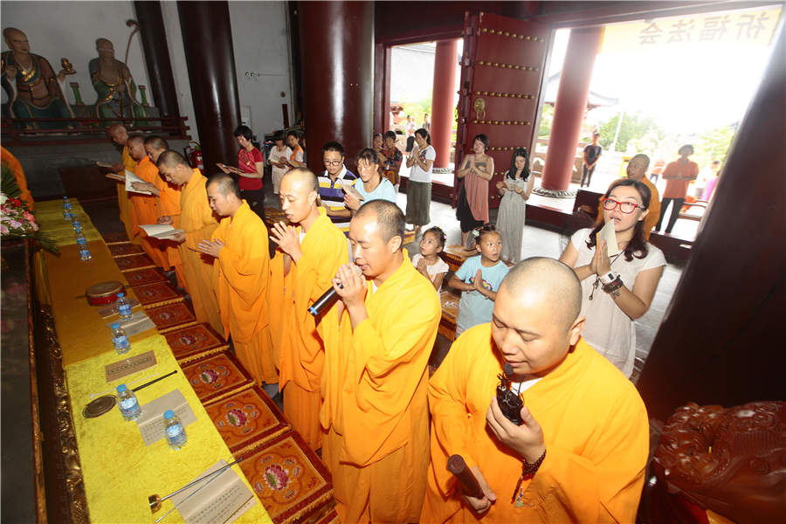

An Ullambana ceremony is held to rescue the deceased from bad situations at a temple in Hainan on the Ullambana Festival, August 10, 2014. [Photo/VCG]

**The legend of Mulian Saves His Mother**

The Ullambana Festival is related to the legend of Mulian Saves His Mother.

It is said that after going through innumerable trials and hardships in the nether world, Mulian finally saw his mother, only to find her being tortured by a group of hungry ghosts. Mulian wanted to send his mother rice and dishes with an earthen bowl, but the food was snatched by the hungry ghosts. Mulian had no choice but to ask Buddha for help.

Moved by his filial piety, Buddha presented Mulian with the Ullambana Sutra and told him to participate in an Ullambana Fast on July 15 of the lunar calendar. On that day, food of various kinds as well as five fruits -- peaches, plums, apricots, chestnuts and dates -- should be provided to all Buddhist monks.

Under the instruction of the Ullambana Sutra, Mulian filled the Ullambana vessel with fruits and vegetarian food to offer a sacrifice to his mother on July 15. His starving mother finally got the food. To show his gratitude to the Buddha, Mulian held an almsgiving activity every year to release the hungry ghosts from the disaster of being hanged by their feet.

The day has become a festival to honor departed ancestors, relatives and friends.

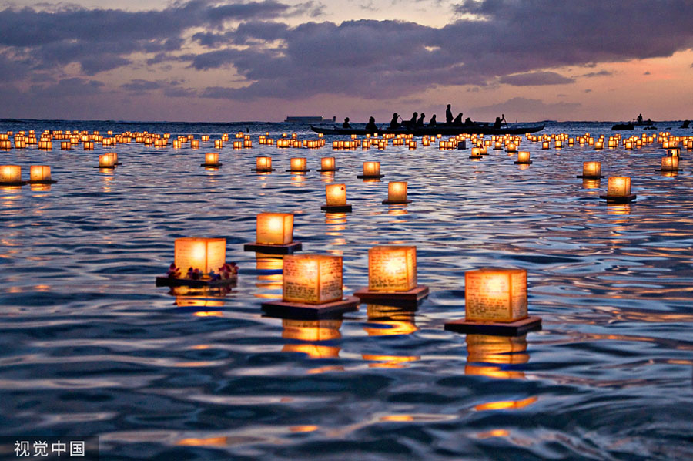[Photo/VCG]

**Floating water lantern**

Among the various folk customs of the Zhongyuan Festival, the floating water lantern is the grandest. The water lantern, also called lotus lantern, is usually made by pasting paper into a lotus shape. Then a lamp or candle is placed inside. On the night of the Zhongyuan Festival, lanterns are released into rivers or lakes.

People think that they should hang out lanterns to celebrate the ghosts. As human beings and land belong to yang, which means positive, so ghosts and water belong to yin, which means negative. The dark and mysterious underworld usually reminds people of the gloomy sepulchral hell where the ghosts suffer. So lanterns are floated on the waters.

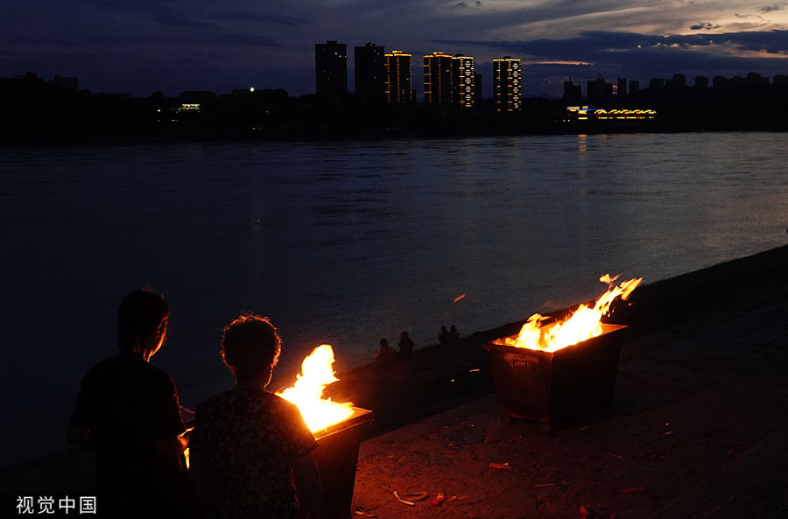

[Photo/VCG]

**Burning paper "money"**

It is said in folklore that departed ancestors will be released by Yama for half a month. As a result, there is a custom to welcome ancestors at the beginning of July and send them off on July 15. When sending off the spirits, people will burn a lot of paper "money" so ancestors can spend it in the nether world. They will also insert some paper "money" into an envelope on which the user's name has been written. The envelope will be burnt for sacrifice.

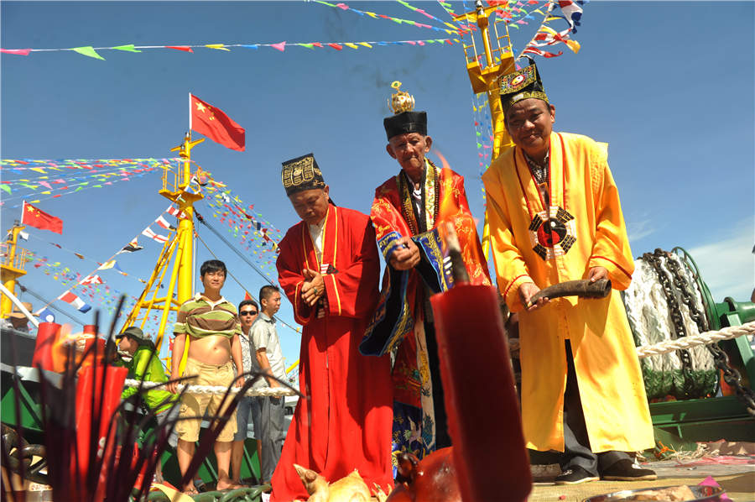

A sea sacrificial ceremony is held in Qionghai of Hainan province during Zhongyuan Festival to pray for good fortune, August 9, 2014. [Photo by Meng Zhongde/Asianewsphoto]

**Sending goat**

A popular folk custom during the festival requires that a grandfather or uncle on the mother's side send a live goat to his grandson or nephew. Legend has it that the custom has something to do with the myth of Chenxiang Saving His Mother from the Mountain. The custom has gradually evolved into sending a pair of flour goats.

The festival is quite popular among Chinese and is celebrated not only on the Chinese mainland, but also in Hong Kong and Taiwan. Besides, it has spread to and is celebrated in Thailand, Japan, Singapore and Malaysia.

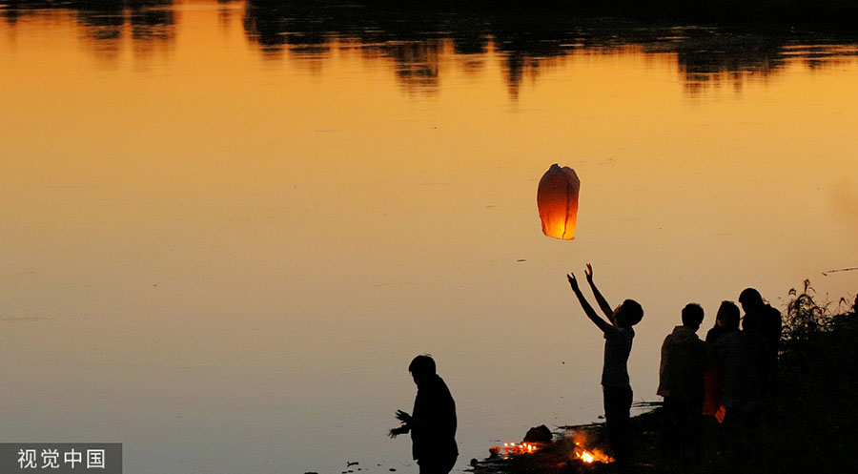

[Photo/VCG]

**Taboos**

According to ancient Chinese customs, there are some activities that should be avoided during the Zhongyuan Festival to stop the evil spirits from hurting you.

1. Don't hang wet clothes at night

Hanging wet clothes at night will easily attract spirits and is like setting a trap to capture ghosts.

2. Don't sleep with your hair untied

During the Zhongyuan Festival, there are ghosts hanging around everywhere, and if your hair is disheveled and loose, the ghosts will consider you as one of their league members.

3. Don't celebrate birthday at night.

If you celebrate birthday at night, you may encounter "something else" singing the birthday song with you. So it's better to celebrate at daytime.

4. Don't take photos at night

You may capture spirits when taking photos at night, and then they will follow you home.

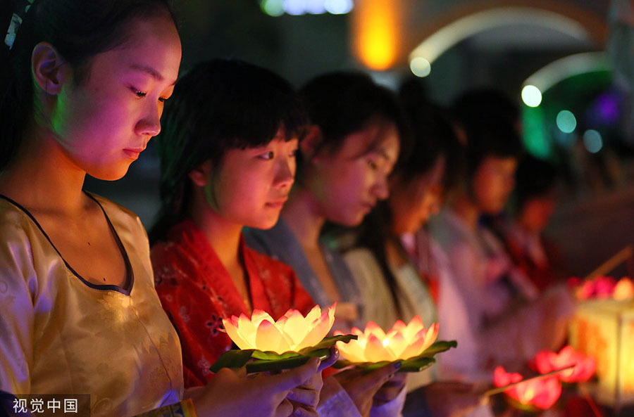

Photo/VCG]

5. Don't say the word "ghost"

The ghosts are everywhere during Zhongyuan Festival, so it's better and safer to not say the word "ghost", and also don't say other improper words, in case they decide to take revenge on you.

6. Don't step on paper ghost money

The paper ghost money is sacrifice for spirits, and ghosts are always gathering around the money. If you step on their money, they will be angry and may harm you.

7. Don't pat other people's shoulders

The folklore believes that there are three bunches of fire on each person, head and two shoulders, to avoid evil spirits. If you pat other people's shoulder, you may make their protective fire die out.

8. Be careful in turning your head

If you are walking in forest or a sparsely populated area, and if you hear someone calling you, don't turn around, you may see something scary.

During the Ghost Festival, just go home early and try to have a vegetarian diet.